EASY FUNDS FOR FORSYTHE!
AMAZON SMILE
If you shop online, please consider supporting Forsythe through the AmazonSmile program. It's easy to do and doesn't cost you anything. 1. Go to smile.amazon.com. 2. Select "Parent Teacher Organization Forsythe Junior High School" as your charitable organization. 3. Start at smile.amazon.com, then shop normally. Amazon.com does NOT get us the sales percentage. You must shop on smile.amazon.com.
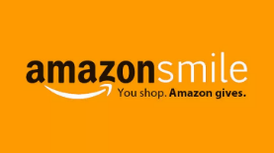
You can also activate AmazonSmile on the Amazon app. 1. Open the Amazon Shopping app on your phone. 2. Go into the main menu of the Amazon Shopping app and tap into “Settings”. 3. Tap “AmazonSmile and follow the on-screen instructions to complete the activation.

GROCERY PROGRAMS
Support Forsythe while you do your grocery shopping. These stores donate a percentage of your purchase to our school. We recommend checking your enrollment annually in that in some instances re-enrollment is necessary.
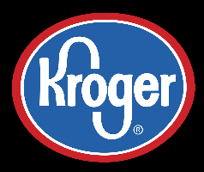
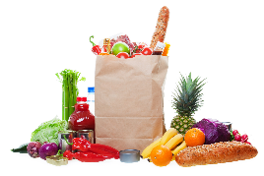
Get a reward card at any Kroger store. Enroll at www.kroger.com/account/ EnrollCommunityRewardsNow.
Tell them at check out to link your purchase with Forsythe Middle School.
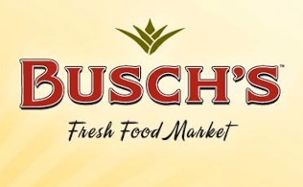
Follow the directions at www.buschs.com/community to link your MyWay account to Forsythe.

BOX TOPS FOR EDUCATION
HOW TO EARN? BOX TOPS MAKES IT EASY.
No more clipping. No more sending Box Tops to school. All you need is your phone. Download the ALL-NEW Box Tops app, shop as you normally would, then simply scan your store receipts to find participating products. The app will automatically credit your school's Box Tops earnings online. Twice a year, your school will receive a check and can use that cash to buy whatever it needs!

